|  |  |  |
| --- | --- | --- |
|  | **CMPS 350 Project Phase 1 – WebApp UI Design and Implementation**  **Conference Management System (ConfPlus)**  **(20% of the course grade)** | |
| **Group Members:** | | Moustafa Elbeltagy(201903412)  Marwan Hasnish(201701546)  Ifran Rafi (201909090)  **Emails:** mh1701546@student.qu.edu.qa; me1903412@student.qu.edu.qa;  ir1909090@student.qu.edu.qa; |
|  | |  |

**Grading Rubric - In the Functionality column please specify either: *Working (completed x%)*, *Not Working (completed x%)* or *Not done*.**

|  |  |  |  |  |
| --- | --- | --- | --- | --- |
| **Criteria** | **%** | **Functionality\*** | **Quality of the implementation** | **Your Grade** |
| **Application Design:** Entities, Repositories and Web API class diagrams, flow diagrams | 10% |  |  |  |
| **Complete and correct implementation of the requirements:** | **80%** |  |  |  |
| * Login | 10 | Working (completed 100%) |  |  |
| * Submit paper | 20 | Working (completed 90%) |  |  |
| * Review paper | 20 | Working (completed 90%) |  |  |
| * Create/update conference schedule | 20 | Working (completed 100%) |  |  |
| * Get conference schedule | 10 | Working (completed 100%) |  |  |
| **Testing, documentation, and group work:**   * Use screen shots to illustrate your tests. * For every team member detail the list of accomplished tasks by the member, **and** the overall contribution percentage to the project (%). * Team coordination: describe in a concise way how the team members collaborated to achieve the project. List the collaboration tools that you have used, if any   **All of these elements should be reported in the template below** | 10% |  |  |  |
| **Total** | 100 |  |  |  |
| Copying and/or plagiarism or not being able to explain or answer questions about the implementation | -100% |  |  |  |

**\* Possible grading for functionality** - ***Working*** (get 70% of the assigned grade), ***Not*** ***working*** (lose 40% of assigned grade and ***Not done*** (get 0). The remaining grade is assigned to the quality of the implementation.

In case your implementation is not working then 40% of the grade will be lost and the remaining 60% will be determined based on of the code quality and how close your solution to the working implementation.

Solution quality also includes meaningful naming of identifiers (according to Android naming conventions), no redundant code, simple and efficient design, clean implementation without unnecessary files/code, use of comments where necessary, proper code formatting and indentation.

**Marks will be reduced** forcode duplication, poor/inefficient coding practices, poor naming of identifiers, unclean/untidy submission, and unnecessary complex/poor user interface design.

# Current status of the project implementation

List of fully implemented use-cases / functionalities:

* Use Case 1: Login
* Use Case 4: Create/update conference schedule.
* Use Case 5: Get conference schedule.

partially implemented use-cases / functionalities:

* Use Case 2: Submit a paper (90%) – After submitting the paper, we have managed to get the link of the paper but haven’t managed to show the pdf.
* Use Case 3: Review paper (90%) – we haven’t managed to load the review into the review form if it’s already reviewed.

# Application Design

# Entities class diagram

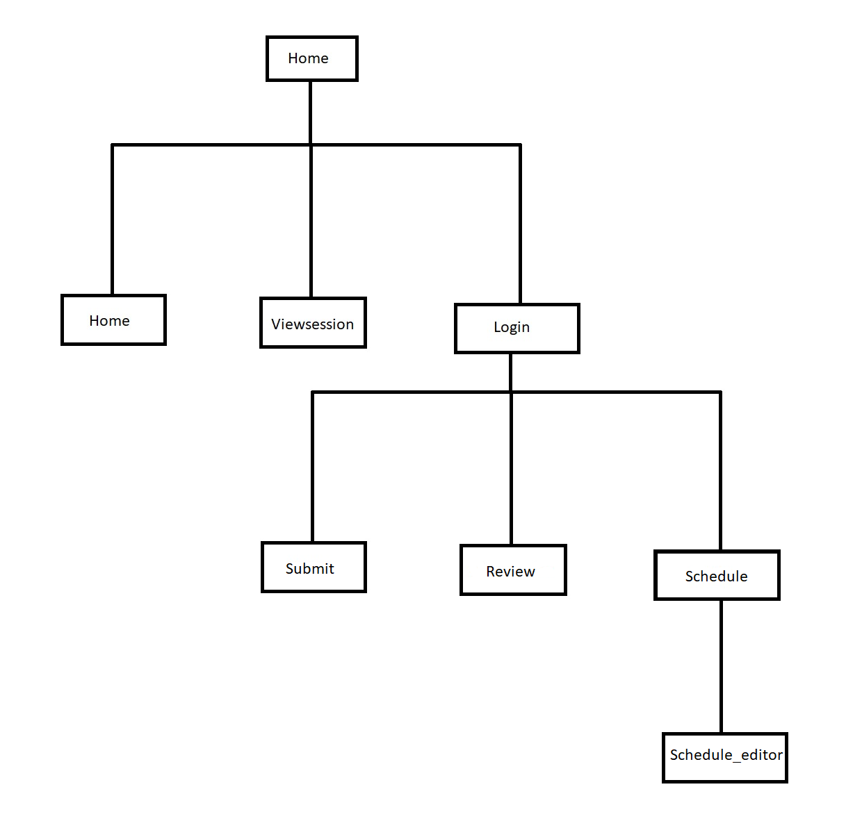

# Repositories class diagram

# Web API class diagram

# Testing

# Login

# Submit paper

# Review paper

# Create/update conference schedule

# Get conference schedule

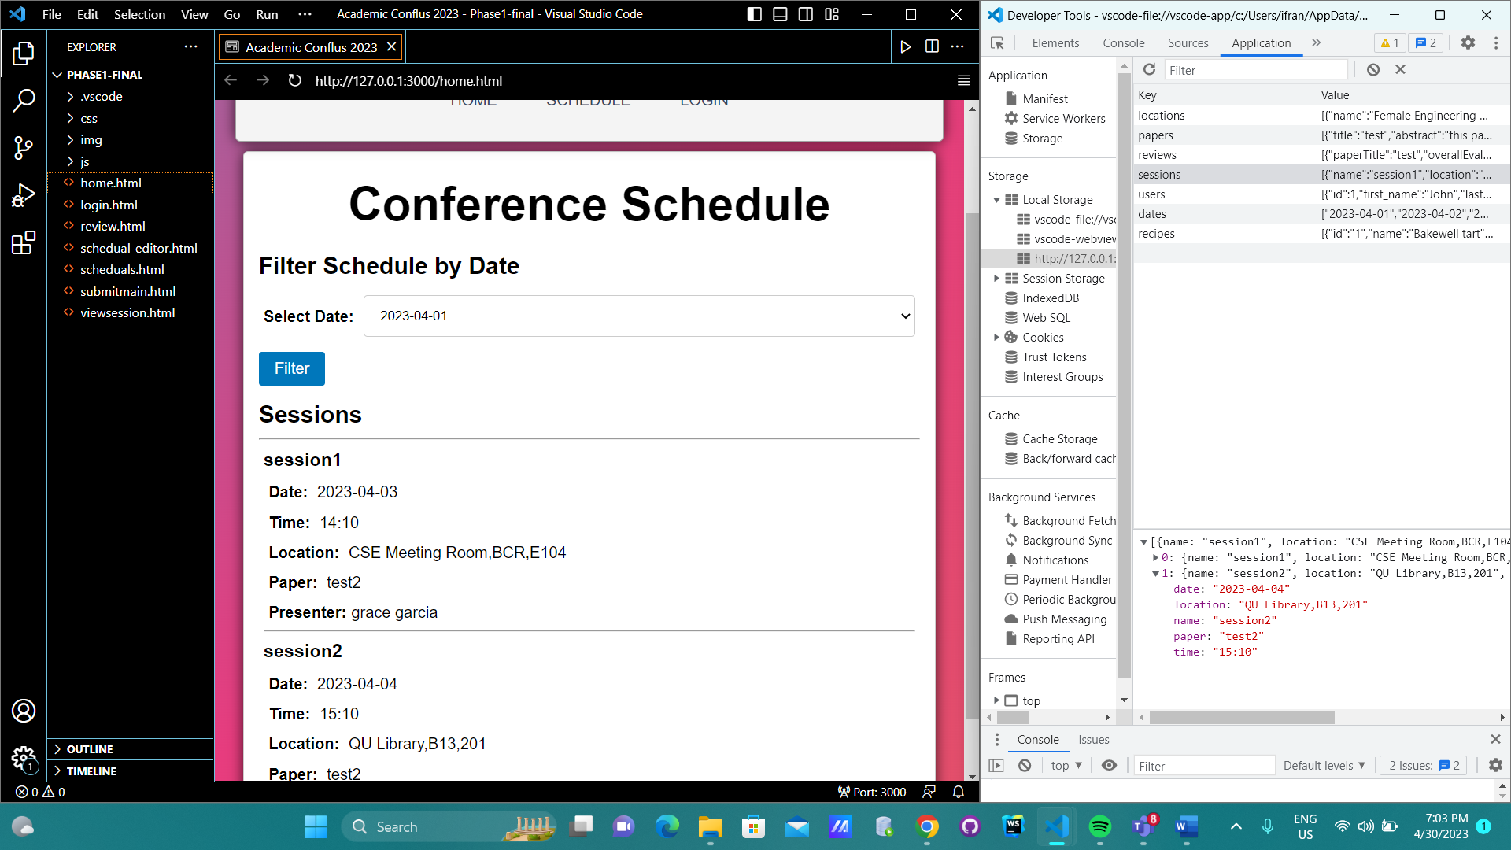

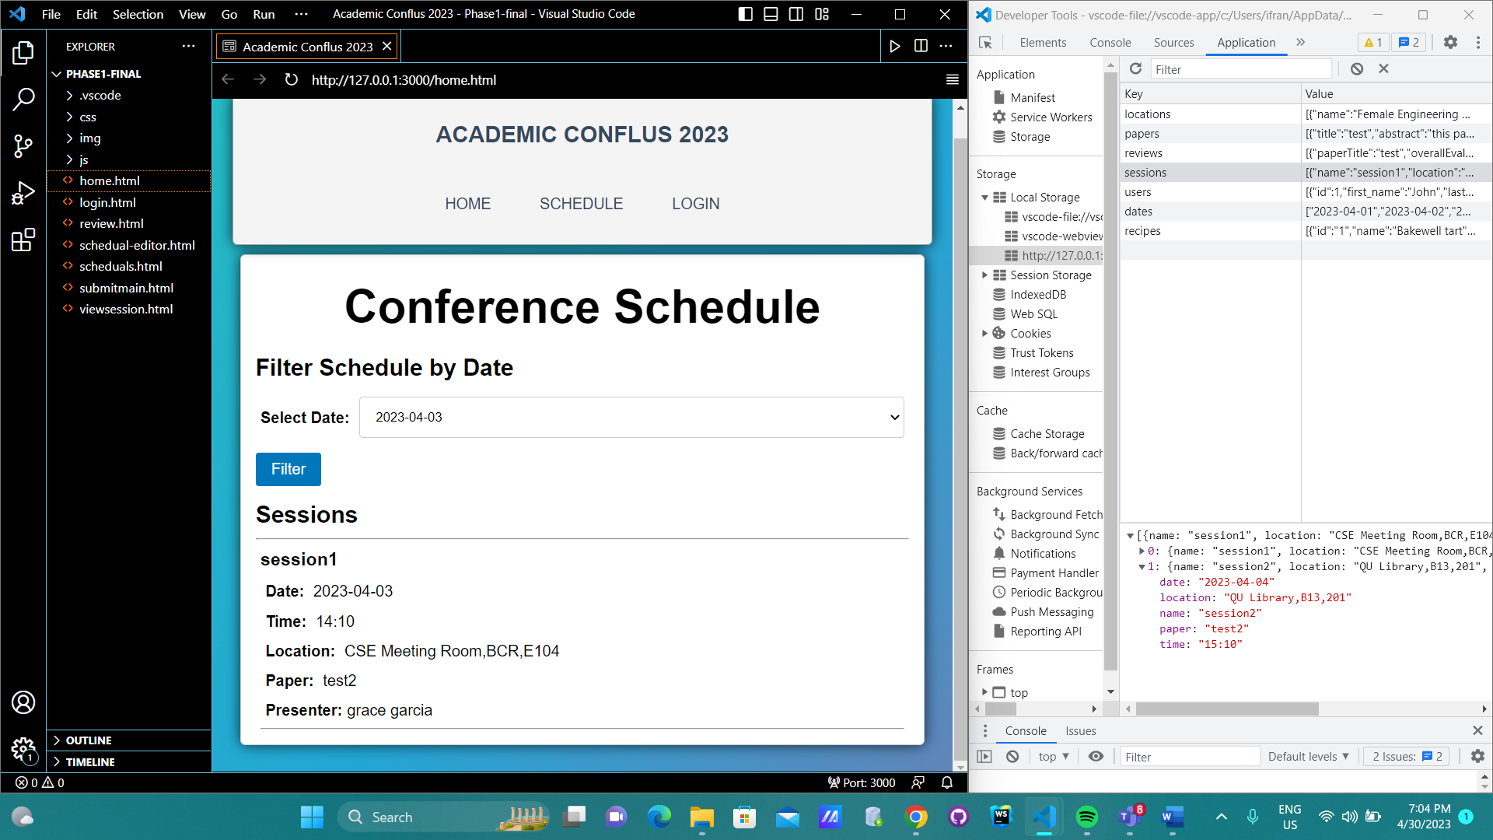

# Discussion of the project contribution of each team member

# Team member contributions

* Moustafa Elbletagy - review, schedule, schedule editor (35%).
* Marwan Hasnish – Home, Login, submit main (35%).
* Ifran Rafi - view session, filtering session and report handling (30%).

# Team coordination

As a big portion of the project was done during the vacation, we were using virtual communication to collaborate on the project. We were using the app “zoom Meetings” to discuss our project and progress. Most often, we were discussing and sharing our codes through WhatsApp. We started from a base code, were working on different use cases individually and sharing that updated code daily. Every time, we made any changes, we used to comment that on the files and mention that in WhatsApp.